Organization
Representative
Address, street, number
PC 00000 – City, Country

Location, date

Subject: ARTCademy Erasmus+ Project. Invitation to become part of the ARTCademy network as member of the Green Art House.

Dear Mr./Ms. XXXX,
Artisan and traditional crafts represent a valuable European heritage that must be protected and cared, and that requires the preservation of knowledge and skills of traditional and guild trades as well as the economic and commercial viability of these firms.
This is the main topic of the Erasmus+ Strategic Partnership ARTCademy,
The University/Organization/Business […] is responsible for coordinating that effort within [country name]. This means that we ask other organizations willing to contribute to the development of artisan and craft sectors that could help to aim the project purposes. Your role as member of the Green Art House section is mainly focused on supporting and expanding the impact of the project, by providing new contents for our Craftpedia area.
By doing so, you could generate several valuable benefits such as described in the attached fact sheet, where you can find additional information about the project.
We would be pleased if you find this proposal interesting for your organization and join the project as a member of the Green Art House.
If you have any questions, do not hesitate to contact us.

Yours sincerely,

ArtCademy Partner
Name of responsible person at your institution
Email: youremail@yourdomain.eu

ARTCademy “Arts and Crafts Academy”

FACT SHEET

CONTEXT
Programme: | Erasmus +
Key Action: | Cooperation for innovation and the exchange of good practices
Action: | Strategic Partnerships for vocational education and training
Main objective: | Innovation
PROJECT IDENTIFICATION
Project Title: | Arts & Traditional Crafts Academy
Project Acronym: | ARTCademy
Project Duration | 24 months
Start Date: | 01-11-2018
End Date: | 31-10-2020
Coordinating Organisation: | University of Málaga
Budget: | 228.421,00 EUR
Agreement number: | 2018-1-ES01-KA202-050514

Objectives

ARTCademy is a knowledge-based project, which aims to preserve and strengthen the European artisan and traditional crafts sector, in two ways: first, keeping and protecting ancestral knowledge concerning to traditional jobs particularly these in risk of disappearing; second, providing to these sector’s firms tools and skills for their survival and development as profitable businesses.

Partnership

ARTCademy brings together 9 partners from 7 European countries.
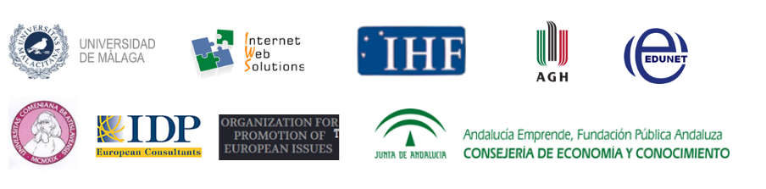

Your benefit as a ARTCademy G.A.H. associate partner

- Being part of Erasmus+, a 30-old year programme, which has been recognized as essential for building a European common space and identity.
- Strengthening cooperation and networking between organizations.
- Promoting the development, testing, and implementation of innovative practices.
- Visibility for your institution is all spaces where the project will be exhibited.
- Using of the Erasmus+ official logo.
- Participation or collaboration in all Project activities which can be carried out by your institution.
- Host international events such as dissemination events, transnational meetings, etc.
- Acquisition of expertise and technical skills in managing, developing and implementing Erasmus+ projects.
- Being part of a consolidated and high qualified network team.
- Participate in future projects as partner.

Your task

- Contribute to the implementation of specific Project tasks/activities
- Support the dissemination and sustainability of the project
- Host international dissemination events, transnational meetings and other activities for project visibility.
- Collect additional information from their stakeholders and target groups concerning the project activities.
- Search for new associated partners in their own networks.

Further information

Project website and OER platform: www.artcademy.eu
Project email address: artcademy@uma.es
Social media:
https://twitter.com/artcademy_eu
https://www.facebook.com/Artcademy-510338659472197/
https://www.instagram.com/artcademy.eu/?hl=es adapt to your own language

ARTCademy “Arts and Crafts Academy”

REGISTRATION FORM FOR MEMBERS OF GREEN ART HOUSE

Contact Data
Name:
Address:
Telephone number:
Language:
Email:
Category:
Description:
More info (with http://):
Password: | Autogenerated
Logo:

Social Networks
Facebook:
Twitter:
Instagram:
Pinterest:
LinkedIn:
Etsy:

I, NAME OF THE PERSON WHO SIGNS, the undersigned, representing NAME OF THE INSTITUTION, agree to be registered as Associate Member at Green Art House of the Erasmus + ARTCademy Project, and I declare that the information I have given on this form is complete and correct to the best of my knowledge and belief.
By signing this registration form, we commit ourselves to participating in the dissemination and mentioned activities.

In CITY, COUNTRY, INSERT DATE

[SIGNATURE, STAMP]

